**Churn Analysis**

Pct_gender

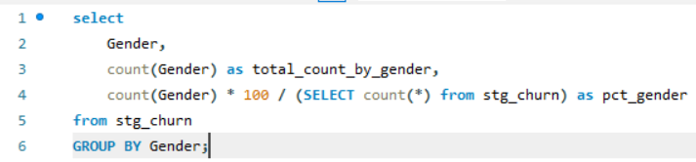

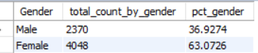

Pct_contract

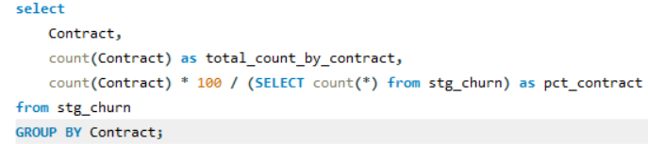

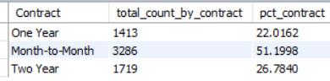

Pct_revenue_by_customer_status

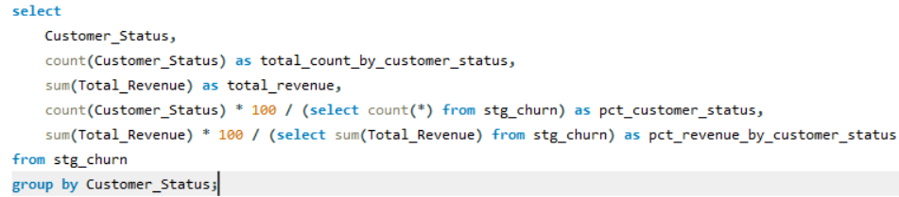

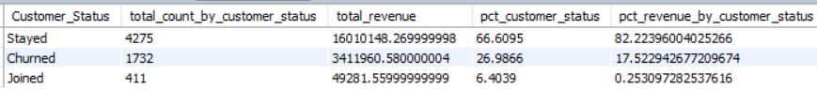

Top 5 pct_state

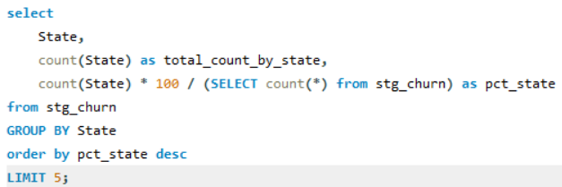

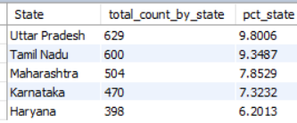

Check missing values in per columns:

SELECT

SUM(CASE WHEN Customer_ID = "" THEN 1 ELSE 0 END) AS Customer_ID_Null_Count,

SUM(CASE WHEN Gender = "" THEN 1 ELSE 0 END) AS Gender_Null_Count,

SUM(CASE WHEN Age IS NULL THEN 1 ELSE 0 END) AS Age_Null_Count,

SUM(CASE WHEN Married = "" THEN 1 ELSE 0 END) AS Married_Null_Count,

SUM(CASE WHEN State = "" THEN 1 ELSE 0 END) AS State_Null_Count,

SUM(CASE WHEN Number_of_Referrals IS NULL THEN 1 ELSE 0 END) AS Number_of_Referrals_Null_Count,

SUM(CASE WHEN Tenure_in_Months IS NULL THEN 1 ELSE 0 END) AS Tenure_in_Months_Null_Count,

SUM(CASE WHEN Value_Deal = "" THEN 1 ELSE 0 END) AS Value_Deal_Null_Count,

SUM(CASE WHEN Phone_Service = "" THEN 1 ELSE 0 END) AS Phone_Service_Null_Count,

SUM(CASE WHEN Multiple_Lines = "" THEN 1 ELSE 0 END) AS Multiple_Lines_Null_Count,

SUM(CASE WHEN Internet_Service = "" THEN 1 ELSE 0 END) AS Internet_Service_Null_Count,

SUM(CASE WHEN Internet_Type = "" THEN 1 ELSE 0 END) AS Internet_Type_Null_Count,

SUM(CASE WHEN Online_Security = "" THEN 1 ELSE 0 END) AS Online_Security_Null_Count,

SUM(CASE WHEN Online_Backup = "" THEN 1 ELSE 0 END) AS Online_Backup_Null_Count,

SUM(CASE WHEN Device_Protection_Plan = "" THEN 1 ELSE 0 END) AS Device_Protection_Plan_Null_Count,

SUM(CASE WHEN Premium_Support = "" THEN 1 ELSE 0 END) AS Premium_Support_Null_Count,

SUM(CASE WHEN Streaming_TV = "" THEN 1 ELSE 0 END) AS Streaming_TV_Null_Count,

SUM(CASE WHEN Streaming_Movies = "" THEN 1 ELSE 0 END) AS Streaming_Movies_Null_Count,

SUM(CASE WHEN Streaming_Music = "" THEN 1 ELSE 0 END) AS Streaming_Music_Null_Count,

SUM(CASE WHEN Unlimited_Data = "" THEN 1 ELSE 0 END) AS Unlimited_Data_Null_Count,

SUM(CASE WHEN Contract = "" THEN 1 ELSE 0 END) AS Contract_Null_Count,

SUM(CASE WHEN Paperless_Billing = "" THEN 1 ELSE 0 END) AS Paperless_Billing_Null_Count,

SUM(CASE WHEN Payment_Method = "" THEN 1 ELSE 0 END) AS Payment_Method_Null_Count,

SUM(CASE WHEN Monthly_Charge IS NULL THEN 1 ELSE 0 END) AS Monthly_Charge_Null_Count,

SUM(CASE WHEN Total_Charges IS NULL THEN 1 ELSE 0 END) AS Total_Charges_Null_Count,

SUM(CASE WHEN Total_Refunds IS NULL THEN 1 ELSE 0 END) AS Total_Refunds_Null_Count,

SUM(CASE WHEN Total_Extra_Data_Charges IS NULL THEN 1 ELSE 0 END) AS Total_Extra_Data_Charges_Null_Count,

SUM(CASE WHEN Total_Long_Distance_Charges IS NULL THEN 1 ELSE 0 END) AS Total_Long_Distance_Charges_Null_Count,

SUM(CASE WHEN Total_Revenue IS NULL THEN 1 ELSE 0 END) AS Total_Revenue_Null_Count,

SUM(CASE WHEN Customer_Status = "" THEN 1 ELSE 0 END) AS Customer_Status_Null_Count,

SUM(CASE WHEN Churn_Category = "" THEN 1 ELSE 0 END) AS Churn_Category_Null_Count,

SUM(CASE WHEN Churn_Reason = "" THEN 1 ELSE 0 END) AS Churn_Reason_Null_Count

FROM stg_churn;